Artic Carbon Reduction Plan

January 2026

Commitment to achieving Net Zero

This Carbon Reduction Plan summarises our current organisational carbon footprint and the environmental management measures we will apply to reduce emissions year-on-year.

Artic Building Services Ltd is committed to achieving Net Zero greenhouse gas emissions by 2050 (at the latest) and to delivering continual, measurable reductions in absolute emissions with a minimum of 90% absolute carbon reduction and 10% Offset for any unavoidable residual CO₂.
Artic are committed to continuing Carbon Neutrality from 2025 onwards through the funding of climate changing initiatives that support the reduction of global emissions, by offsetting all Carbon emissions produced in business actions in line with GHG Protocol and PAS 20/60 guidelines, with the goal and understanding that that there will be a continuous focus on reducing absolute carbon emissions.

Company Baseline for Carbon Neutrality is set for the reporting period of 1st of January 2024 - 31st of December 2024, with the intention of promoting carbon neutrality for 2025 and 2026 through the purchase of Verra Certified Carbon Credits and continuous reduction in absolute emissions.

Our greenhouse gas inventory is prepared using the accounting and reporting principles of the GHG Protocol Corporate Standard and is aligned with ISO 14064-1:2018 requirements for organisational GHG quantification and reporting.
Where we make carbon neutrality statements for defined scopes and reporting periods, our approach follows a reduction-first hierarchy aligned with ISO 14068-1:2023, prioritising direct and indirect emission reductions (and value-chain removal enhancements) before using carbon credits to compensate for residual emissions.
This Carbon Reduction Plan has been reviewed internally by the ESG Compliance Manager and approved and signed off at director level in line with publication requirements

Intensity figures are displayed to 2 decimal places. Percentage change is calculated using the underlying unrounded values to maintain accuracy and reproducibility.

PAS 2060 Information requirement | Information as it relates to PMI affiliates
Entities making declarations | Artic Building Services Ltd
Individual responsible for the evaluation and provision of the data necessary for the substantiation of the declaration (inc. preparing, substantiating, communicating and maintaining the declaration) | Kevin Turner  ESG Compliance Manager
Subject of declaration | Scope 1, 2 and 3 under operational control of Artic Building Services
Function of subject | Hard FM
Activities required for subjects to fulfil its function | Servicing, installation and maintenance of:  - Plumbing  - Heating  - HVAC  - Electrical systems  Soft FM services are subcontracted
Rationale for selection of the subjects | Artic’s ambition is to be carbon neutral for all direct operations (Office, fleet and processes) by 2025. In this journey, all subjects that have reached substantial emission reduction in the  past years qualify to compensate residual emissions and become carbon neutral.
Type of conformity assessment undertaken | Third party, 10% Materiality, Reasonable level of assurance
Reference date for reporting | Jan 1st – Dec 31st 2025
Commitment period | Jan 1st – December 31st 2025

Permissible declaration

Artic Building Services’ greenhouse gas (GHG) reporting is prepared using recognised accounting principles consistent with the GHG Protocol and aligned with ISO 14064-1:2018 for organisational GHG quantification and reporting.

Where Artic makes carbon neutrality statements for clearly defined scopes and reporting periods, our approach follows a reduction-first hierarchy consistent with ISO 14068-1:2023 (quantify → reduce → compensate residual emissions) and draws on established carbon neutrality practice historically set out in PAS 2060.

This Carbon Reduction Plan (CRP) is produced in line with the PPN 006 Technical Standard, including our current carbon footprint and our commitment to achieve Net Zero by 2050 (at the latest), and has been maintained through certified management systems and reviewed internally by the ESG Compliance Manager, then approved/signed off at director level in accordance with CRP publication requirements.

ISO 50001 (Energy Management System) – Artic operates an energy management framework based on continual improvement, using data and objectives/targets to drive year-on-year energy performance improvement. Certified by British Assessment Bureau.

ISO 14001 (Environmental Management System) – Artic operates an environmental management system to manage environmental aspects/impacts, meet compliance obligations and drive continual improvement (PDCA approach). Certified by British Assessment Bureau.

Carbon Reduction

50.33% Absolute Reduction from 2020 company baseline to 2026 but an increase of 9.32% in emissions from 2024-2025 due to technology spending.
15.0% increase on Carbon reduction per employee based on total emissions ÷ total number of staff from 1.5 tCO2e to 1.7 tCO2e.
Per employee calculation based on emissions from head office, employee consumption and commuting as Artic is only responsible for emissions produced by head office and its employees as client specific sites are responsible for their own emissions.
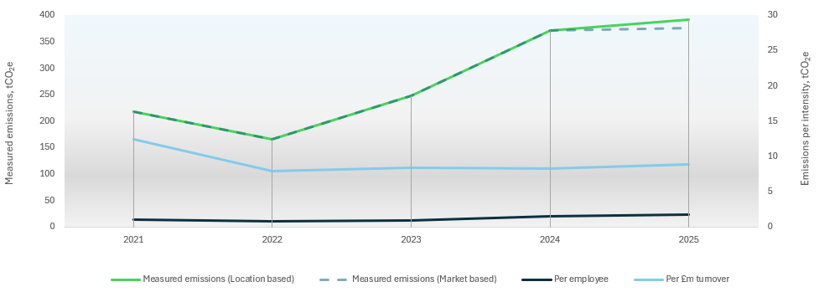

Baseline Emissions Footprint
Our emissions baseline captures our organisational greenhouse gas (GHG) inventory in tCO₂e and covers Scope 1 (direct), Scope 2 (purchased energy) and the relevant Scope 3 value-chain categories where data is available and material. The baseline is prepared in line with the GHG Protocol Corporate Accounting and Reporting Standard (and, for value chain categories, the GHG Protocol Scope 3 Standard) and is consistent with the principles of ISO 14064-1 for organisational GHG quantification and reporting. Where Scope 3 categories are not yet fully quantified, these are transparently identified as data gaps with a plan to expand coverage over time as part of continual improvement.

Reporting year:
01 January 2024 to 31 December 2024
Reporting Boundary:
Unit 16-17 Schooner Park, Schooner Court, Dartford, Kent, DA2 6NW
Emissions measured:
Electricity, T&D Losses, Water, Waste, Fleet, Business travel, Employee commuting, Paper
Notes:
Data for scopes 1, 2 and Scope 3 Category 1,3,5 were sourced from 2024 company records. Scope 3 Category 6 calculations were used in baseline and 2024 Planet Mark submissions. Additionally, category 7 commuting data was extracted from a 2024 travel survey. Due to the response rate of 29%, the remaining proportion of travel emissions was estimated using distance travelled via post code in accordance with GHG protocol calculations on employee commuting. The estimated proportion of the baseline did not account for car sharing to avoid biasing the results, due to the limited size of the sample data.
Total carbon emissions by Scope for year ending 2024, tCO₂e
Baseline year emissions:
EMISSIONS | TOTAL (tCO₂e)
Scope 1 | 196.3
Scope 2 | Electricity (Location Based): 17.9
Scope 3  (Included Sources) | 1 Purchased goods and services: 39.9  3 Fuel and Energy related activities 1.3  4 Upstream Transportation and Distribution 2.1  5 Waste Generated in Operations 0.08  6 Business Travel 8.58  7 Employee Commuting 92.3  Total: 144.3
Total Emissions | 358.67(market-based)
Per Employee | 1.5

Current Emissions Reporting

Reporting year:
01 January 2025 to 31 December 2025
Reporting Boundary:
Unit 16-17 Schooner Park, Schooner Court, Dartford, Kent, DA2 6NW
Emissions measured:
Electricity, T&D Losses, Water, Waste, Fleet, Business travel, Employee commuting, Paper
Notes:
Data for scopes 1, 2 and Scope 3 Category 1,3,5, 6 were sourced from 2025 company records. Additionally, category 7 commuting data was extracted from a 2025 travel survey. Due to the response rate of 30.2%, the remaining proportion of travel emissions was estimated using distance travelled via post code in accordance with GHG protocol calculations on employee commuting. The estimated proportion of the baseline did not account for car sharing to avoid biasing the results, due to the limited size of the sample data and lack of engagement on record.
Total carbon emissions by Scope for year ending 2025, tCO₂e
EMISSIONS | TOTAL (tCO₂e)
Scope 1 | 215.9
Scope 2 | Electricity (Location): 16.9
Scope 3  (Included Sources) | 1 Purchased goods and services: 65.71  3 Fuel and Energy related activities 1.3  4 Upstream Transportation and Distribution 2.1  5 Waste Generated in Operations 0.05  6 Business Travel 3.19  7 Employee Commuting 86.9  Total: 159.3
Total Emissions | 392.09 (Location)
Per Employee | 1.7

Total carbon emissions by Scope 3 for year ending 2025, tCO₂e

Emissions reduction targets - Methodology, Governance & Assurance

Emissions are calculated by converting activity data (e.g., fuel, electricity, refrigerants, travel, water/waste and purchased goods/services where applicable) into tCO₂e using published conversion factors and documented assumptions. The ESG Compliance Manager owns and maintains the GHG methodology, applies document control/versioning, and reviews calculations for completeness, consistency and reasonableness prior to publication. This work is supported by the organisation’s certified management systems (ISO 9001 / ISO 14001 / ISO 50001) to ensure robust control of records, compliance obligations, energy performance improvement, and continual improvement. Our Carbon Reduction Plan is completed in accordance with the UK Government’s CRP technical standard (PPN 006), including formal internal approval and sign-off requirements. Social Value measurement is reported separately using the National TOMs framework (Themes, Outcomes and Measures) for transparent public-facing accountability.

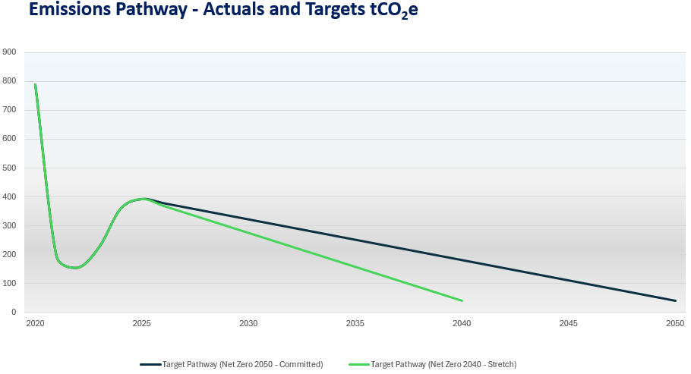
The 2050 pathway is our committed Net Zero trajectory for UK operations (PPN CRP requirement). The 2040 pathway is a stretch ambition to accelerate decarbonisation, reviewed annually through management review and our GHG inventory QA.

Completed Carbon Reduction Initiatives
The following environmental management measures and projects have been completed or implemented since the 2020/21 baseline. The carbon emission reduction achieved by these schemes equate to 356.97 tCO₂e, a 55% reduction against the 2020/21 baseline. Artic continue to review, implement and monitor carbon reduction measures to reduce our organisational carbon footprint, as well as the carbon emissions associated with performing our contracts.
This will be achieved and based on extracting and reporting more data regarding Scope 3, creating a more realistic and detailed overall look at the company’s emissions.
Below provides a summary of our strategy, Artic Zero.
Practising what we preach

Since 2013, we have taken many steps in moving our business on the road towards net zero:
- October 2013 – 77.83 tCO₂e saved. We relocated offices to Dartford due to having over 80% of head office staff living within a 15-mile radius, lowering carbon emissions from travel.
- November 2019 - We implemented efficient water and heating solutions by adding sensors to our water, heating, lighting, and AC systems, preventing the use of unnecessary energy outside of office hours.
- May 2020 – 1.15 tCO₂e & £423.49 saved. We purchased 4 electric vans for our fleet. making 2% of our fleet now being electric and the start of becoming cleaner in our travel.
- August 2021 – 2.89 tCO₂e & £2358.10 saved. By installing 100% LED lighting throughout our HQ, we increased our lighting energy efficiency.
- September 2021 – We achieved Planet Mark Accreditation which recognises our commitment to continuous improvement, measuring and reducing our carbon emissions, energy and water consumption, and travel and waste.
- March 2022 – The Founding of Artic Zero. We created Artic Zero to support businesses with achieving net zero.
- August 2022 – We achieved reducing our carbon emissions by 5%.
- September 2022 – Earth Hero App – All employees to utilise the ‘Earth Hero’ app to reach individual sustainability goals.
- September 2022 – Installing electric charging point at our Head Office to support, encourage and reduce the reliance on fossil fuels.
- January 2023 – New CAFM system – Implemented new CAFM system to reduce paper usage by 38%.
- April 2023 – Cycle to work - 5% of employees using cycle-to-work scheme.
- June 2023 – Energy sensors installed assess power and energy consumption within the office to monitor and address heavy energy usage.
- September 2023 – Solar installation Stage 1, 2.34 tCO₂e & £2058.74 saved.
- September 2023 – Artic awarded ISO 50001 in energy management.
- November 2023 – 1.8 tCO₂e & £622.74 saved. Increase to our EV fleet.
- May 2024 – Solar Stage 2, 14.05 tCO₂e & £13,423.28 saved.
- July 2024 – 9.7 tCO₂e & £3595.75 saved. The Artic electric fleet hit 7.69%.
- July 2024 – 3.39 tCO₂e & £2976.28 saved. Energy sensor monitoring showed AC was still powered on at weekends and public holidays. A new more advanced controller was installed to control this.
- February 2025 – Carbon neutrality – Artic have become carbon neutral.
- June 2025 – Carbon Neutral certified. Artic achieves PAS20/60 external Verification of all data pertaining to Scopes 1, 2 and 3 and its validity of all company claims pertaining to carbon neutrality and the purchase of carbon offsetting.

Our future plans
But we’re not stopping there; we have plenty of plans in the pipeline:
- April 2026 – Paper usage reduction – Reduce paper consumption by 80%.
- August 2026 – Solar panels – Reach stage 3 of solar panel installation at Artic head office to reduce overall carbon footprint.
- December 2026 – Electrical fleet – 20-30% of Artic fleet to be electric.
- December 2026 – Supply chain – 5% of supply chain to have ISO 14001/50001 of policy to show commitment.
- January 2027 – Carbon emissions – To achieve a 5% carbon emissions reduction per employee.
- Ongoing – Carbon Net Zero.
- Increase Electric Fleet
- Promote Artic Zero sustainability team and initiatives

To see our net zero roadmap: see https://www.articbuildingservices.com/road-map/

Declaration and Sign Off
This Carbon Reduction Plan has been completed in accordance with PPN 006 and associated guidance and reporting standard for Carbon Reduction Plans.
Emissions have been reported and recorded in accordance with the published reporting standard for Carbon Reduction Plans and the GHG Reporting Protocol corporate standard and uses the appropriate Government emission conversion factors for greenhouse gas company reporting.
Scope 1 and Scope 2 emissions have been reported in accordance with SECR requirements, and the required subset of Scope 3 emissions have been reported in accordance with the published reporting standard for Carbon Reduction Plans and the Corporate Value Chain (Scope 3) Standard.
This Carbon Reduction Plan has been reviewed and signed off by the board of directors (or equivalent management body).

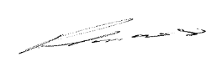
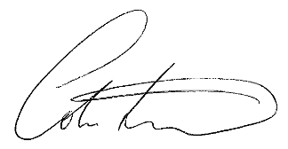

Colin Trowell Paul Lucas
Managing Director Managing Director

Artic Building Services Limited
Jan 2026

https://ghgprotocol.org/corporate-standard
https://www.gov.uk/government/collections/government-conversion-factors-for-company-reporting
https://ghgprotocol.org/standards/scope-3-standard

